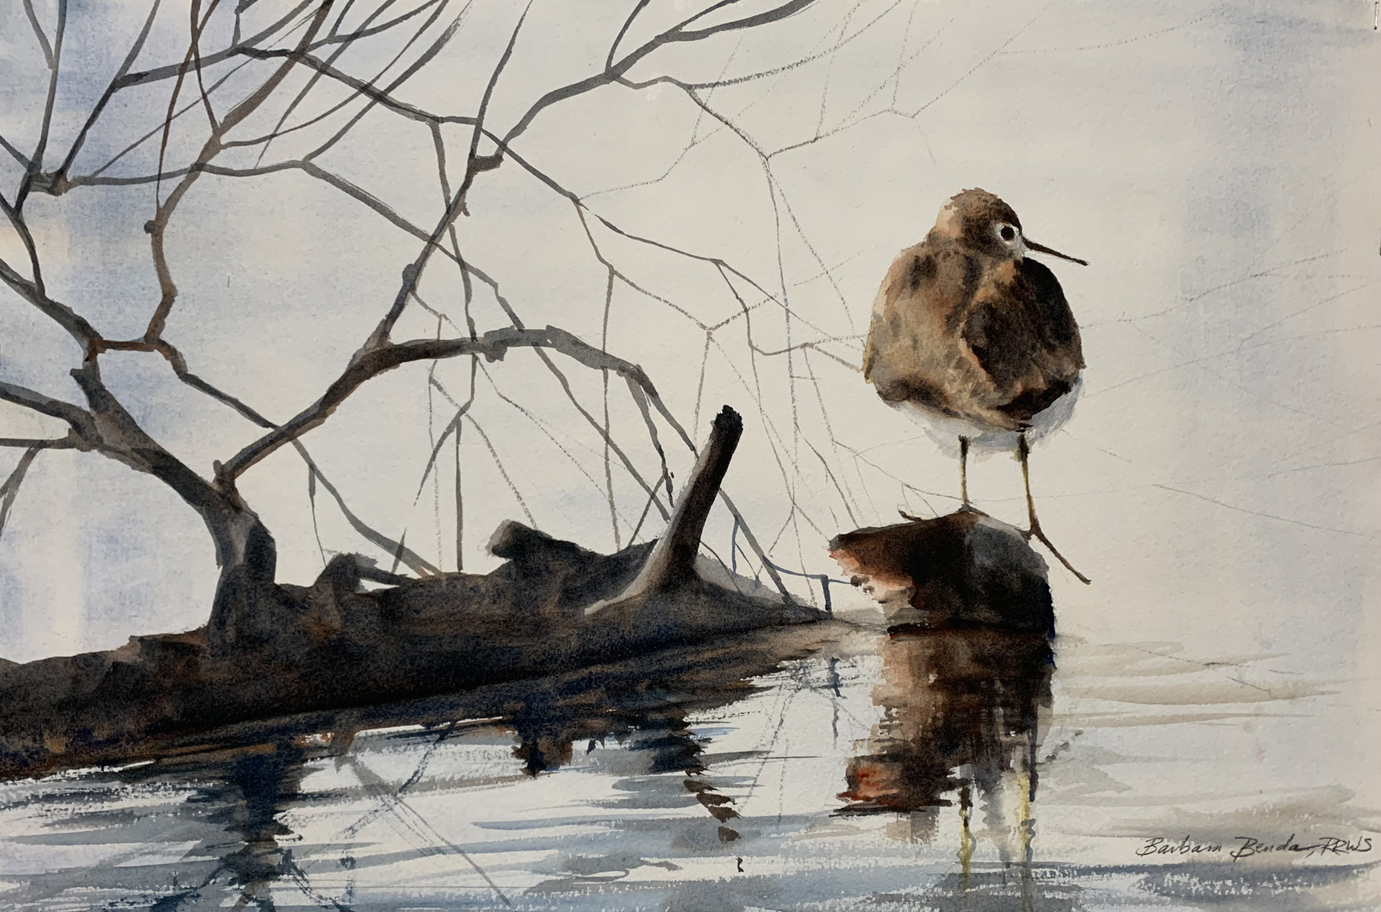

Beginning Drawing and Watercolor 5-Day Workshop
Barbara Benda, Instructor

Professional artist and teacher Barbara Benda will be providing her unique curriculum for learning to draw and paint. With over 40 years of teaching experience, she simplifies complex art concepts so all levels of learners may succeed.

This workshop includes sketching techniques, understanding the color wheel, how to use lights and darks to create contrast, and learning about composition to create successful watercolor paintings. All exercises start at the beginning and proceed step-by-step.

Date: January 12-16th, 2026
Time: 9:00 am to 3:30 pm Monday through Friday with lunch on your own
Location: Vista Center for Education Room #120
Cost: $425 plus professional-grade supplies. Download the Supply list at www.barbarabenda.net and email barbara@barbarabendanagle.com with any questions. Limited ready-made supply kits are available for $225 by contacting instructor.

Participant Profile: for all levels of learner, ages 15 and up.

Class is limited to 15 students. Minimum number of students is 8.

Photo attached: Solitary Sandpiper: Lost in Thought by Barbara Benda

